Changes to request to Ting
EOS MCP page
- “EOS MCP” should be in capital letters in all buttons

- Reminder: A video will show here, I should be sending it on Friday. I’d just like to flag that the video should show inside a screen, just as we do in other pages. Example: Flexible energy page


- Can we please merge Introduction and Overview and just make it Introduction?


- Update the text “What is an MCP?”



- Update image
(file attached to email)

 | 



Resources – AI-Powered Workflows page:

- Remove the 2 please: 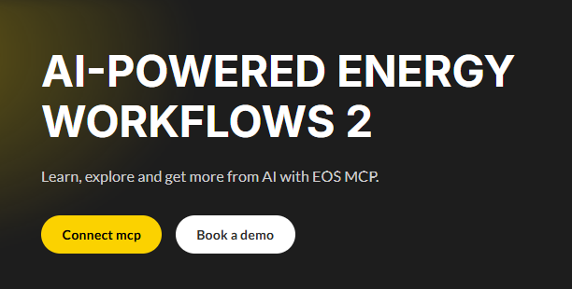
- Replace Overview with Introduction
- Remove “Why AI is changing the energy market intelligence”
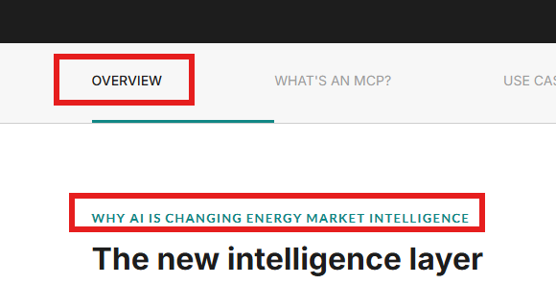

- Update image: I’m attaching an image with some slight changes
Currently | New
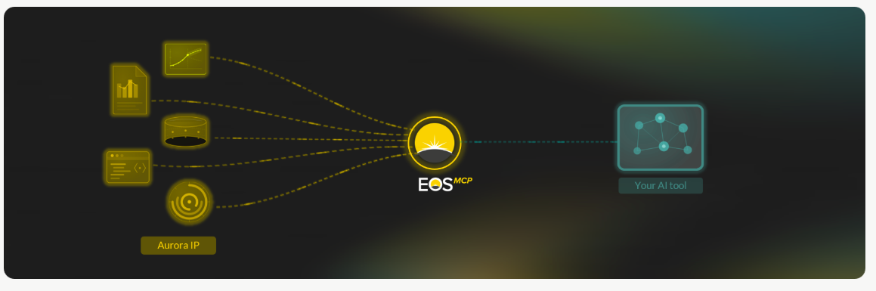 | 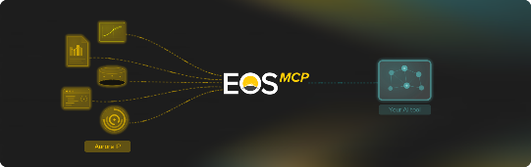

- Videos: find the link with the videos here:
Case study | Title | Phrase
Australia battery spreads vs revenue | Test whether wider price spreads pay batteries | Compare two-hour spreads with fleet revenue across four Australian states, split into wholesale and FCAS, in one prompt.
Belgium solar | Quantify the value of switching off at negative prices | See how much a Belgian solar plant's 2026 capture price improves if it stops generating through negative-price periods.
CAISO nodal Sankey | Turn an Aurora report slide into an interactive analysis | Recreate a CAISO nodal Sankey for 2020 vs 2025, add node-level tooltips and map the results, in three prompts.
ERCOT battery margins from Flexplorer | Benchmark battery margins against the wider fleet | Compare ERCOT average, top-decile and bottom-decile margins, then trace the gap to revenue streams, cycling and spreads.
French nuclear availability | Spot nuclear availability dips in the generation mix | See how visible four years of French nuclear outages are in monthly generation, in one prompt.
GB optimiser premium | Size the premium for a better optimiser | Measure what the day's best optimiser earns over a median 2-hour battery on GB's most volatile days.
India DAM price | Check forecasts against market outcomes | Compare Aurora's India day-ahead price band with IEX clearing prices from Q3 2025 to Q1 2026, in one prompt.

- Update these images for clarity:
Current
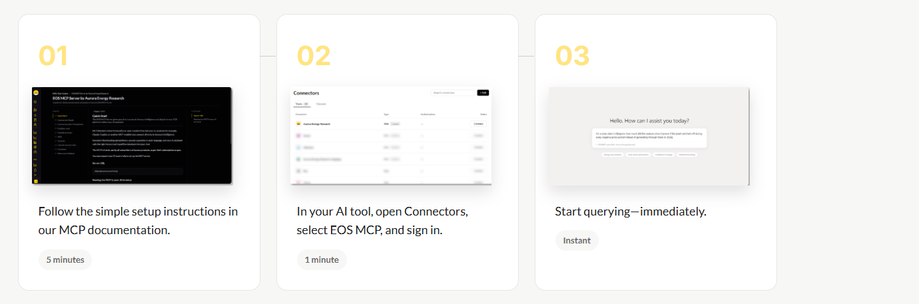
New (attached in email)
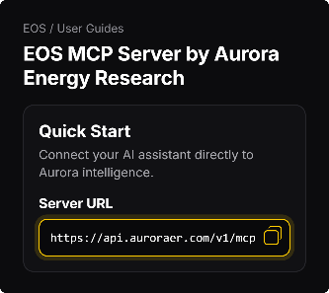 | 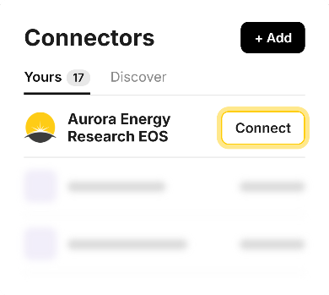 | 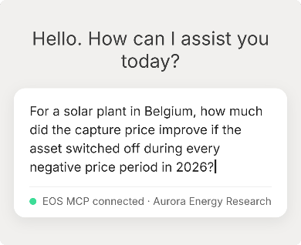

AI & Data
1 – Please change this to AI & Data (Instead of AI and data)
- Replace the EOS AI logo with this version (attached)
- Switch the order of the products (Start with EOS MCP)
- Please remove this:
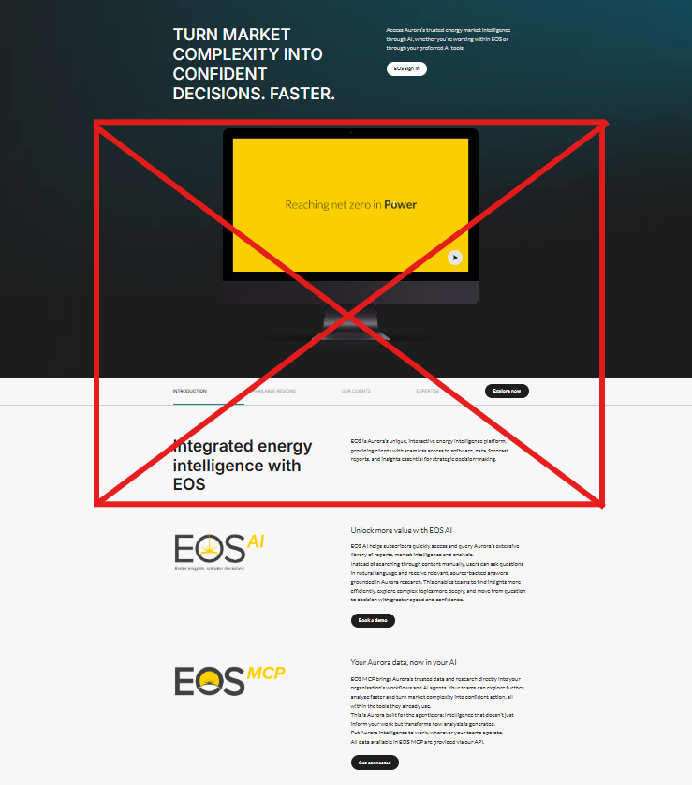

Web structure:
- Please remove the EOS AI page. The content in this page should fall under AI & Data
- Please add a round symbol next to the EOS MCP menu screen. I’m attaching an image you could use. If you need another format, please let me know.
- This is different from our initial request, but could we please place the “AI-Powered Energy workflows” page here, as a sub-page for EOS MCP?
